Install Android Studio

|  |  |
| --- | --- |
| Team ID | PNT2022TMID05098 |
| Project | Containment Zone Alerting Application |

**STEP 1:**  Download Android Studio from respective URL

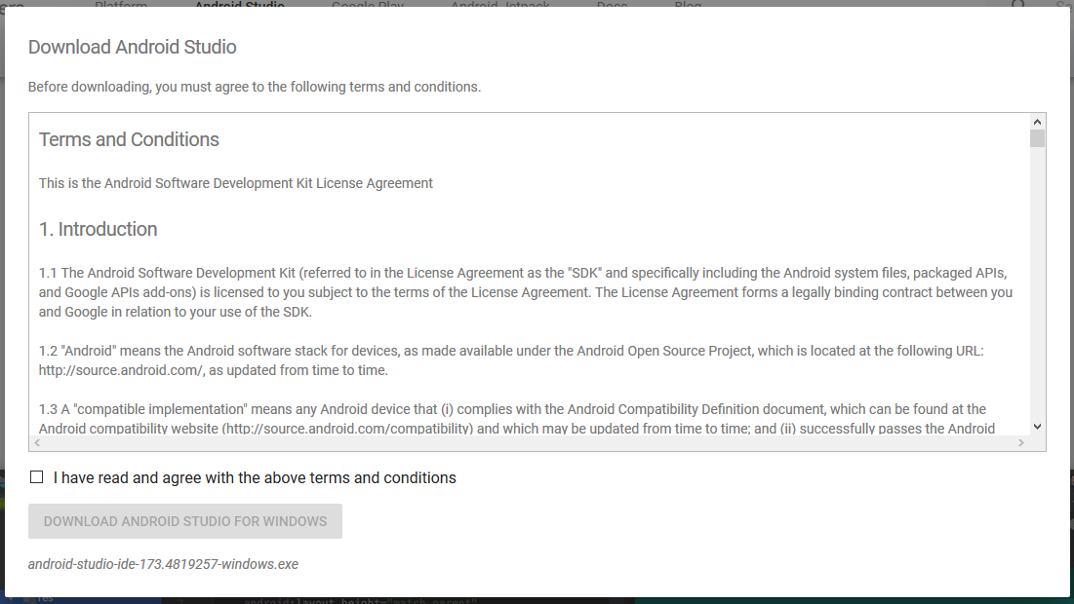

**STEP 2:**  After downloading has finished, open the file and start the installation

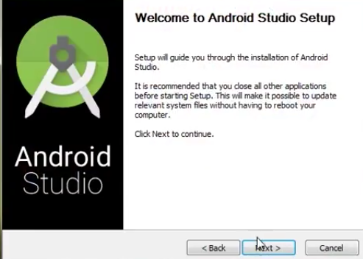

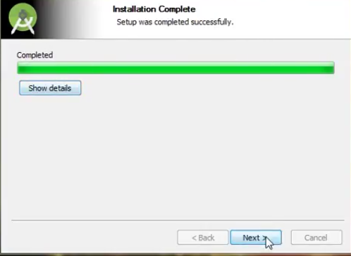

**STEP 3:** After installation completed , click finish and then click ok button

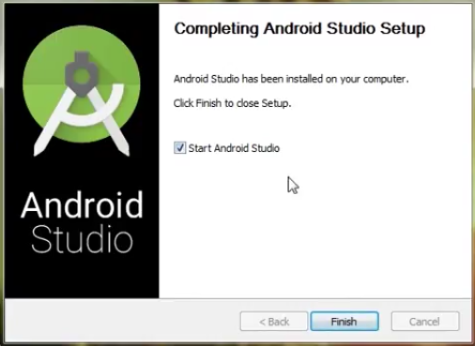



**STEP 4:** Now the Android studio will start then finding the available SDK components,after that it redirect to the Welcom dialog box.

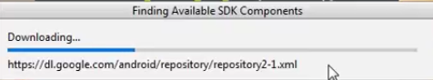

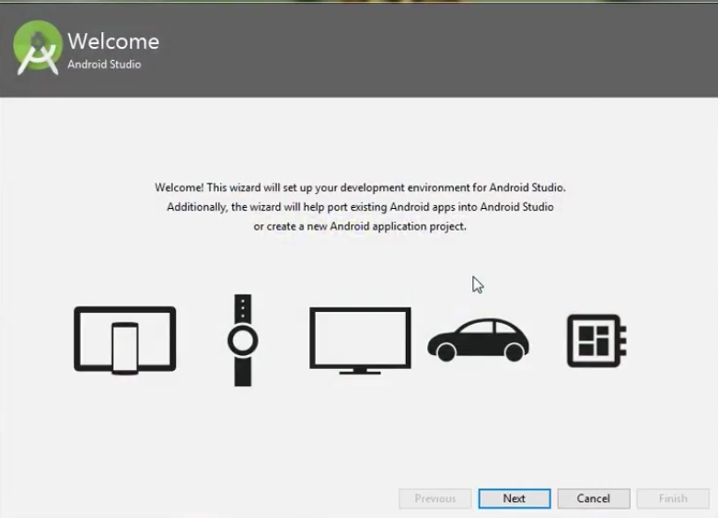

**STEP 5:**  choose the theme and click Next button, now download the SDK components. After completion of download ,click on finish button. Finally click on start a new Android Studio project to build a new app.

